Exp 1: Create a Kanban Board to Visualize the Tasks.
- Create Columns for To Do, In-Progress and Done.
- Add At least 5 Sample Tasks
- Move the Tasks across the Columns to Simulate the Workflow.

Step 1: Open the Kanban Board
- Log in to Jira.
- Open the Task Management project.
- Open the Kanban Board.
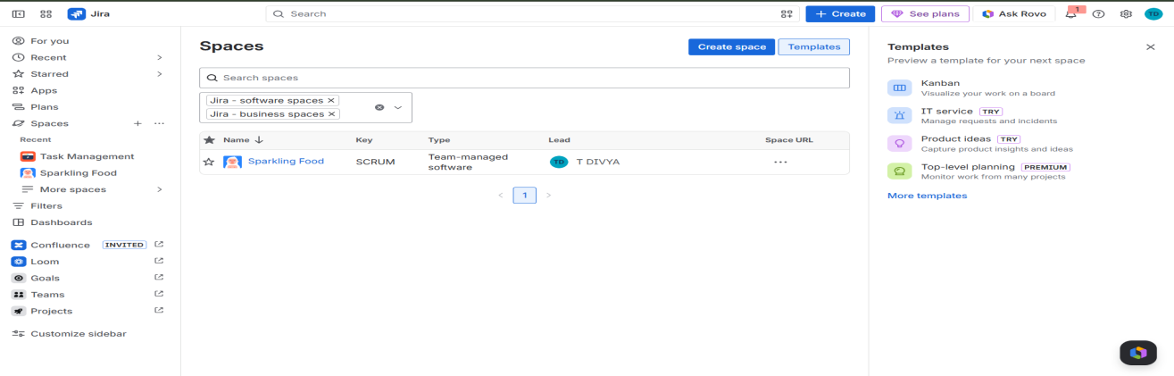
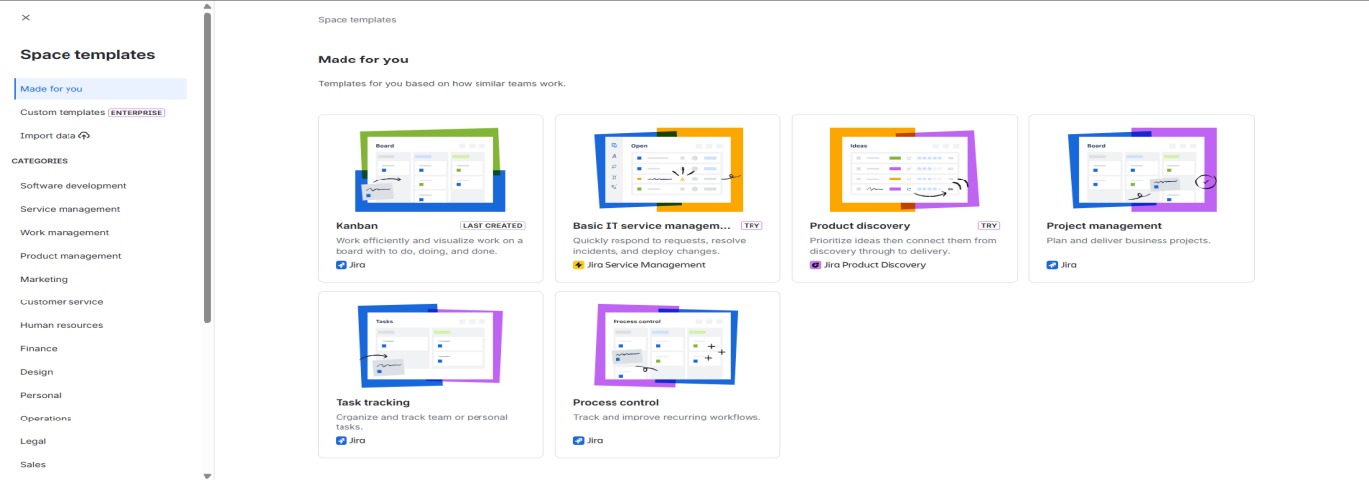
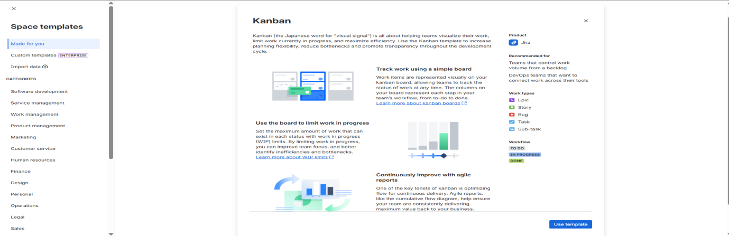

4: Create the Done Column
- Verify that the Done column is available.
- This column is used for completed tasks.
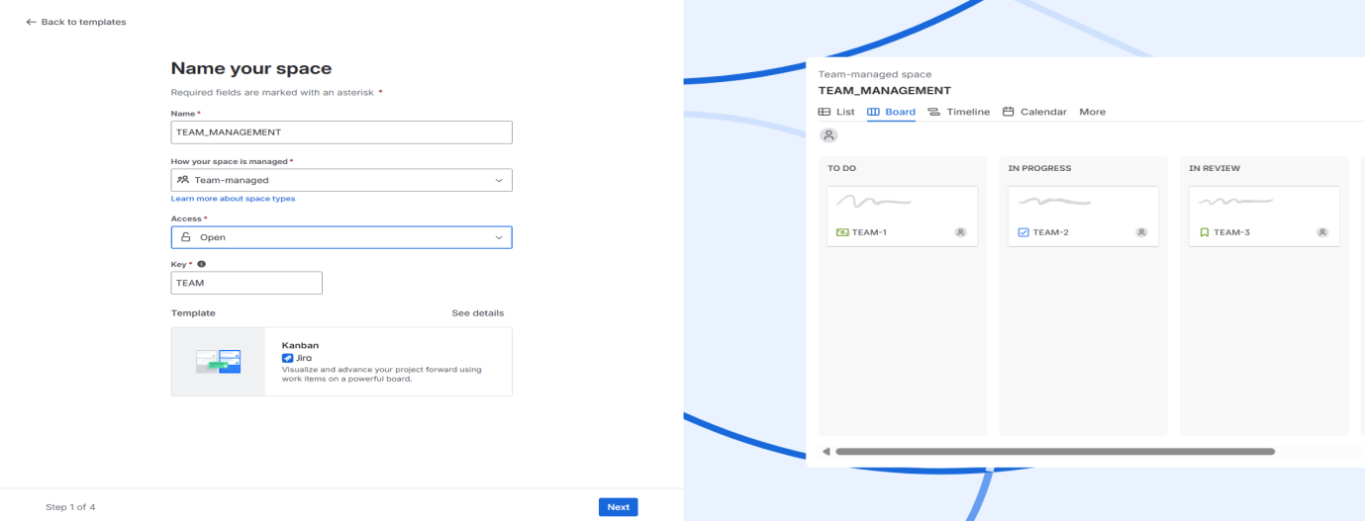

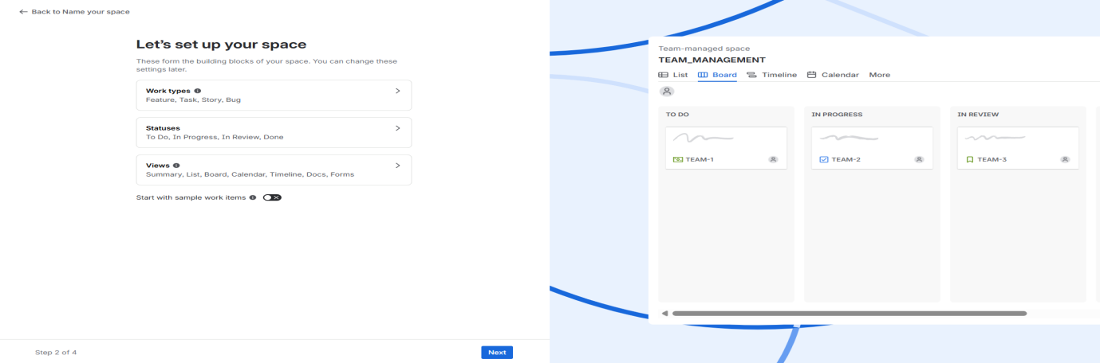
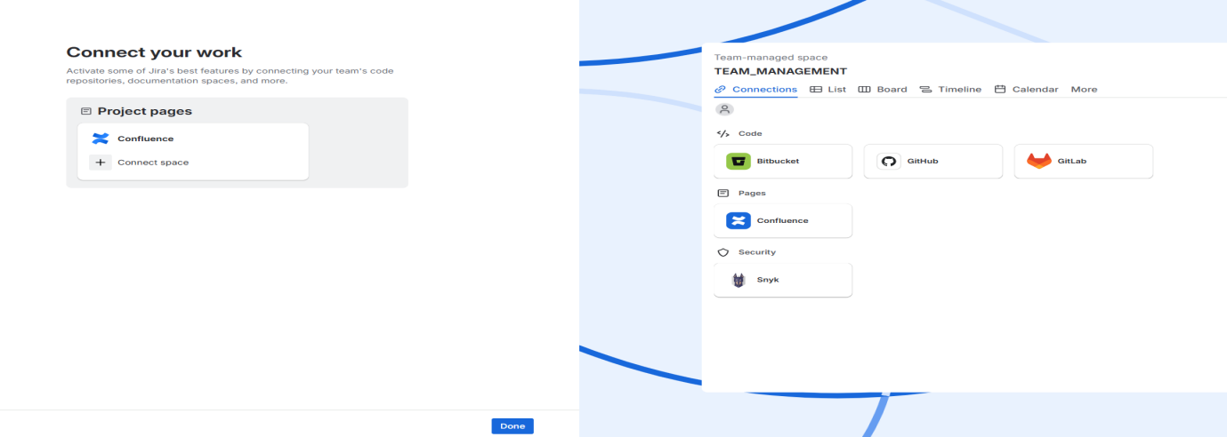

Step 5: Add Sample Tasks
- Click "What needs to be done?" in the To Do column.
- Add five tasks:
  - Gather Requirements
  - Design User Interface
  - Develop Login Module
  - Test Application
  - Deploy Project
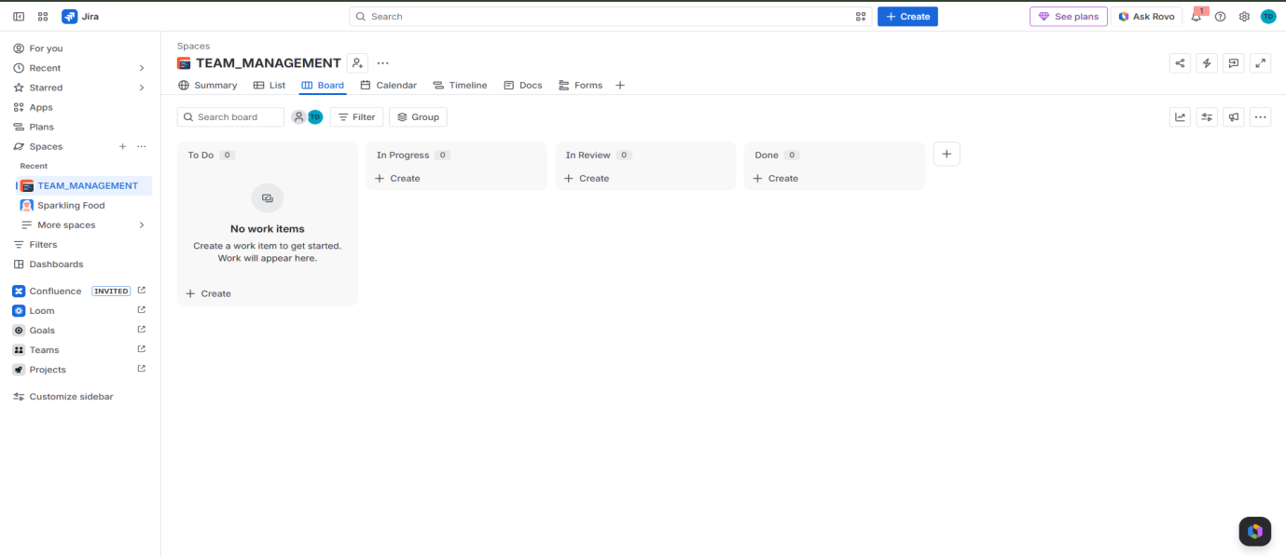

Step 6: Move Task to In Progress
- Drag the Design User Interface task from To Do to In Progress.
- This shows that work has started.

Step 7: Move Task to Done
- Drag the Gather Requirements task to the Done column.
- This marks the task as completed.

Step 8: View Updated Board
- Verify that tasks are displayed in different columns.
- Check that the workflow is updated correctly.
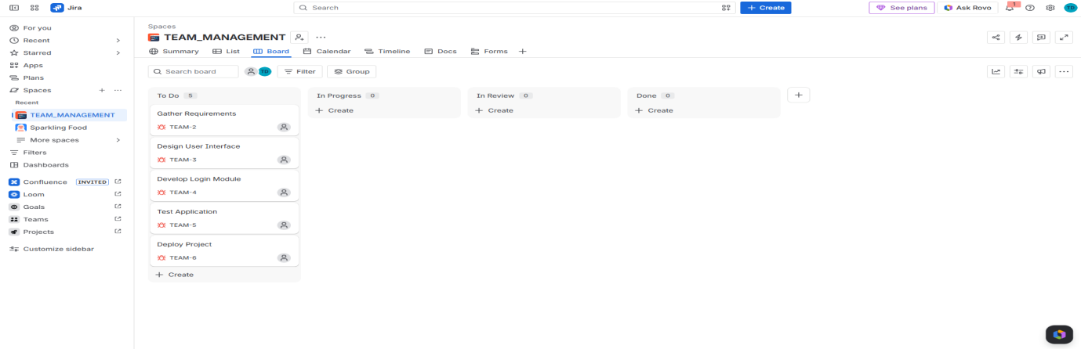

Step 9: Final Kanban Board
- Review the final Kanban board.
- Ensure the tasks are distributed as follows:
  - To Do: Develop Login Module, Test Application, Deploy Project
  - In Progress: Design User Interface
  - Done: Gather Requirements

